**Chapter One**

**Introduction to Accounting**

**1.1 The Nature and Purpose of Accounting**

**1.1.1 Definition of Accounting**

Accounting is the process of recording, summarizing, analyzing, and communicating financial transactions and information about an organization. It involves the systematic and comprehensive recording of financial activities, including purchases, sales, receipts, and payments, in order to produce financial statements such as the balance sheet, income statement, and cash flow statement.

Accounting serves several purposes, including providing information for decision-making, assessing the financial health of an organization, facilitating compliance with tax laws and regulations, and communicating financial performance to stakeholders such as investors, creditors, and management. There are various branches of accounting, including financial accounting, management accounting, tax accounting, and auditing, each serving specific functions within an organization.

**1.1.2 The Nature of Accounting**

The nature of accounting encompasses several key aspects that define its role and function within organizations and society. Here are some of the fundamental aspects of the nature of accounting:

**a) Recording Transactions**: At its core, accounting involves the systematic recording of financial transactions. This includes documenting all monetary exchanges, purchases, sales, expenses, and revenues in a structured manner.

**b) Summarizing Financial Data:** Accounting processes involve summarizing recorded transactions into meaningful financial reports. This includes preparing financial statements such as the balance sheet, income statement, and cash flow statement, which provide an overview of the organization's financial position and performance.

**c) Analyzing Financial Information:** Accountants analyze financial data to derive insights and make informed decisions. This analysis may involve assessing trends, identifying areas of strength or weakness, evaluating financial ratios, and projecting future outcomes based on historical data.

**d) Interpreting Results**: Interpretation of financial information is a crucial aspect of accounting. Accountants interpret financial statements to understand the financial health of an organization, assess its profitability, liquidity, and solvency, and communicate insights to stakeholders.

**e) Compliance and Regulation:** Accounting operates within a framework of laws, regulations, and accounting standards. Compliance with these regulations ensures transparency, accuracy, and reliability of financial reporting, thereby enhancing trust among stakeholders.

**f) Decision Support:** Accounting information serves as a basis for decision-making by providing relevant data to management, investors, creditors, and other stakeholders. It helps in evaluating performance, formulating strategies, allocating resources, and assessing risks.

**g) Communication:** Accounting serves as a language of business, facilitating communication of financial information to various stakeholders. Clear and accurate financial reporting enables effective communication and fosters trust among investors, creditors, employees, and regulatory authorities.

**h) Continuous Improvement:** The nature of accounting involves a continuous process of improvement and adaptation to changing business environments, technological advancements, and regulatory requirements. Accountants need to stay updated with emerging trends, best practices, and evolving standards to ensure relevance and effectiveness in their role.

Overall, the nature of accounting is multifaceted, encompassing both technical and analytical aspects, as well as ethical considerations and professional judgment in the pursuit of accurate and reliable financial reporting.

**1.1.3 The Purpose and Goals of Accounting**

The purposes of accounting are multifaceted, encompassing various objectives that serve the needs of different stakeholders within an organization and in the broader economic context. Here are some key purposes of accounting:

**1. Recording Transactions**

Accounting serves the fundamental purpose of systematically recording financial transactions. This includes documenting purchases, sales, expenses, revenues, and other monetary exchanges to maintain a comprehensive record of the organization's financial activities.

**2. Financial Reporting**

Accounting provides a framework for preparing financial reports such as balance sheets, income statements, and cash flow statements. These reports summarize the financial performance, position, and cash flows of the organization, enabling stakeholders to assess its financial health and make informed decisions.

**3. Decision-Making**

Accounting information supports decision-making by providing relevant data to management, investors, creditors, and other stakeholders. Managers use financial reports to evaluate performance, set goals, allocate resources, and formulate strategies, while investors and creditors use them to assess the profitability, liquidity, and solvency of the organization.

**4. Performance Evaluation**

Accounting facilitates the evaluation of organizational performance over time. By comparing financial data across different periods, stakeholders can analyze trends, identify areas of strength or weakness, and measure the effectiveness of management strategies and operational activities.

**5. Resource Allocation**

Accounting helps in the efficient allocation of resources within an organization. By providing insights into the costs and benefits of different options, accounting information assists management in prioritizing investments, optimizing expenditures, and maximizing returns on capital.

**6. Compliance and Regulation**

Accounting ensures compliance with legal and regulatory requirements governing financial reporting. By adhering to accounting standards and principles, organizations maintain transparency, accuracy, and integrity in their financial statements, thereby enhancing trust among stakeholders and mitigating legal risks.

**7. Taxation**

Accounting plays a crucial role in tax compliance and planning. By accurately recording financial transactions and preparing tax returns in accordance with tax laws and regulations, organizations fulfill their tax obligations and optimize their tax liabilities within the legal framework.

**8. Stakeholder Communication**

Accounting serves as a means of communication between the organization and its stakeholders. Financial reports communicate important information about the organization's financial performance, prospects, and risks to investors, creditors, employees, customers, suppliers, and regulatory authorities.

**9. Risk Management**

Accounting helps in identifying, measuring, and managing financial risks. By analyzing financial data and ratios, stakeholders can assess the organization's liquidity, solvency, creditworthiness, and exposure to various risks such as market risk, credit risk, and operational risk.

**10. Continuous Improvement**

Accounting supports continuous improvement by providing feedback on past performance and insights for future planning. Organizations use accounting information to learn from past experiences, adapt to changing market conditions, and enhance efficiency and effectiveness in their operations.

**1.2. The Objectives of Financial Accounting**

The objectives of financial accounting are fundamental principles that guide the practice of recording, summarizing, and reporting financial information. These objectives help ensure that financial statements provide relevant, reliable, and understandable information to users. Here are the main objectives of financial accounting:

**a) Provide Information to External Users**

Financial accounting aims to provide relevant financial information to external users, such as investors, creditors, regulators, analysts, and other stakeholders who are not directly involved in the day-to-day operations of the company. These users rely on financial statements to make investment decisions, assess the creditworthiness of the company, and evaluate its financial performance and position.

**b) Meet Regulatory Requirements**

Financial accounting aims to comply with legal and regulatory requirements governing financial reporting. Companies must adhere to accounting standards and regulations established by regulatory bodies such as the Financial Accounting Standards Board (FASB) in the United States or the International Financial Reporting Standards (IFRS) globally. Compliance with these standards ensures consistency, comparability, and transparency in financial reporting across industries and jurisdictions.

**c) Facilitate Decision Making**

Financial accounting provides information that helps internal and external stakeholders make informed decisions. Managers use financial statements to assess the financial health of the company, evaluate performance, and make strategic decisions. Investors and creditors rely on financial information to allocate resources, assess risk, and evaluate investment opportunities. Therefore, the objective of financial accounting is to provide timely and relevant information to support decision-making processes.

**d) Assess the Company's Financial Performance**

Financial accounting aims to measure and report the financial performance of a company over a specific period. This involves preparing financial statements such as the income statement, which shows revenues, expenses, and net income, and the statement of comprehensive income, which provides a broader view of the company's financial performance by including items not included in the income statement, such as gains and losses from investments.

**e) Evaluate the Company's Financial Position**

Financial accounting aims to assess the financial position of a company at a specific point in time. This involves preparing the balance sheet, which presents the company's assets, liabilities, and shareholders' equity. The balance sheet provides valuable information about the company's liquidity, solvency, and ability to meet its financial obligations.

**f) Ensure Accountability and Stewardship**

Financial accounting aims to promote accountability and stewardship by providing information about how resources are being used and managed. Financial statements serve as a tool for holding management accountable to shareholders and other stakeholders for the use of company resources and the results of their stewardship.

**g) Facilitate Comparison and Benchmarking**

Financial accounting aims to provide information that allows users to compare the financial performance and position of a company over time and with other companies in the same industry or sector. Consistent accounting principles and standards enable meaningful comparisons and benchmarking, which are essential for assessing competitiveness, identifying trends, and making strategic decisions.

Overall, the objectives of financial accounting are to provide relevant, reliable, and understandable financial information that meets the needs of external users, supports decision making, ensures compliance with regulatory requirements, and promotes accountability and transparency in financial reporting.

**1.3. The Elements of Financial Statements**

The elements of financial statements, also known as financial statement elements or financial reporting elements, are the building blocks used to prepare financial statements. These elements represent the various components of financial transactions and events that are recognized in financial reporting. The elements of financial statements are typically classified into two main categories: balance sheet elements and income statement elements. Here are the primary elements of financial statements:

**(a) Assets**

Assets are resources controlled by the entity as a result of past events and from which future economic benefits are expected to flow to the entity. Examples of assets include cash, accounts receivable, inventory, property, plant, and equipment, investments, and intangible assets such as patents and trademarks.

**(b) Liabilities**

Liabilities are present obligations of the entity arising from past events, the settlement of which is expected to result in an outflow of resources embodying economic benefits. Examples of liabilities include accounts payable, loans payable, bonds payable, accrued expenses, and deferred revenue.

**(c) Equity**

Equity, also known as shareholders' equity or net assets, represents the residual interest in the assets of the entity after deducting liabilities. It reflects the owners' claim on the assets of the company. Equity includes items such as common stock, retained earnings, additional paid-in capital, and accumulated other comprehensive income.

**(d) Income**

Income, also referred to as revenues or sales, represents increases in economic benefits during the accounting period in the form of inflows or enhancements of assets or decreases in liabilities that result in increases in equity, other than contributions from equity participants. Examples of income include sales revenue, service revenue, interest income, and gains from the sale of assets.

**(e) Expenses**

Expenses are decreases in economic benefits during the accounting period in the form of outflows or depletions of assets or incurrences of liabilities that result in decreases in equity, other than distributions to equity participants. Examples of expenses include cost of goods sold, salaries and wages, rent expense, utilities expense, depreciation expense, interest expense, and income tax expense.

**(f) Gains**

Gains are increases in equity during the accounting period from peripheral or incidental transactions and other events and circumstances affecting the entity, except those that result from revenues or investments by owners. Gains typically arise from the sale of assets, investments, or other transactions resulting in an increase in the entity's net assets.

**(g) Losses**

Losses are decreases in equity during the accounting period from peripheral or incidental transactions and other events and circumstances affecting the entity, except those that result from expenses or distributions to owners. Losses typically arise from the sale of assets, write-offs of assets, or other transactions resulting in a decrease in the entity's net assets.

These elements serve as the foundation for preparing financial statements such as the balance sheet, income statement, statement of changes in equity, and statement of cash flows. They are used to classify and measure financial transactions and events, enabling users to assess the financial position, performance, and cash flows of the entity.

**1.4. The Accounting Equation**

The accounting equation, also known as the basic accounting equation or balance sheet equation, is a fundamental principle in accounting that illustrates the relationship between a company's assets, liabilities, and equity. The equation is expressed as:

*Assets* = *Liabilities* + *Equity*

This equation represents the fundamental principle of double-entry bookkeeping, which states that for every transaction recorded, there must be at least two accounts affected, with the total debits equaling the total credits.

Here's what each component of the equation represents:

**Assets:** Assets are economic resources owned or controlled by a company that have measurable value and are expected to provide future benefits. Examples of assets include cash, accounts receivable, inventory, property, plant, equipment, and investments.

**Liabilities:** Liabilities are obligations or debts owed by a company to external parties, such as creditors, suppliers, or lenders. Liabilities represent claims against the company's assets and must be settled or paid off in the future. Examples of liabilities include accounts payable, loans payable, bonds payable, and accrued expenses.

**Equity:** Equity, also known as owner's equity, shareholders' equity, or net worth, represents the residual interest in the assets of the company after deducting liabilities. Equity reflects the owners' claim on the company's assets and represents the amount of capital contributed by the owners plus retained earnings or accumulated profits. It can be further broken down into components such as common stock, additional paid-in capital, retained earnings, and accumulated other comprehensive income.

The accounting equation must remain in balance at all times, meaning that the total assets must equal the total liabilities and equity. This principle is essential for ensuring the accuracy of financial records and statements, as any changes to one side of the equation must be offset by corresponding changes to the other side.

For example, if a company borrows money (increasing assets through cash and increasing liabilities through a loan payable), the accounting equation remains balanced:

*Assets* (*Cash*) = *Liabilities* (*Loan Payable*) + *Equity* (*Owner*′*s Equity*)

In this case, the company's assets (cash) increase, but so do its liabilities (loan payable), maintaining the balance in the equation.

**1.5. The Users of Accounting Information**

Accounting information serves a wide range of users who rely on financial data to make informed decisions about various aspects of an organization's operations, financial performance, and prospects. These users can be broadly categorized into two groups: internal users and external users. Here's a breakdown of the primary users of accounting information:

**Internal Users:**

**a. Management:** Internal users primarily include management personnel within the organization, such as executives, managers, and department heads. They use accounting information for decision-making, planning, controlling, and evaluating the organization's performance. Management relies on financial reports to assess profitability, manage costs, allocate resources, set goals, and formulate strategies to achieve organizational objectives.

**b. Employees:** Employees at different levels of the organization may also use accounting information to understand the financial health of the company, assess their performance against targets, evaluate compensation and benefits, and make decisions about career development or job changes.

**c. Board of Directors:** The board of directors, as representatives of shareholders, relies on accounting information to oversee the company's financial management, governance, and strategic direction. They use financial reports to monitor performance, evaluate risks, approve major decisions, and ensure compliance with legal and regulatory requirements.

**d. Internal Auditors:** Internal auditors play a crucial role in evaluating the effectiveness of internal controls, risk management processes, and compliance with policies and procedures. They use accounting information to assess the reliability of financial reporting, identify weaknesses in internal controls, and recommend improvements to mitigate risks.

**e. Budgeting and Planning Departments:** Departments responsible for budgeting, forecasting, and planning use accounting information to develop budgets, set targets, allocate resources, and monitor performance against predetermined goals. They rely on financial data to make projections, assess variances, and adjust plans as needed to achieve financial objectives.

**External Users:**

**a. Investors and Shareholders:** External users include investors, shareholders, and potential investors who provide capital to the organization. They use accounting information to evaluate the company's financial performance, profitability, growth prospects, and potential risks before making investment decisions. Investors rely on financial statements to assess the company's ability to generate returns and dividends and to determine the value of their investment.

**b. Creditors and Lenders:** Creditors, such as banks, financial institutions, suppliers, and bondholders, use accounting information to assess the creditworthiness and financial stability of the organization before extending credit or lending money. They rely on financial statements to evaluate the company's ability to repay debts, manage liquidity, and honor financial obligations.

**c. Regulators and Government Agencies:** Regulators, government agencies, and tax authorities use accounting information to monitor compliance with legal and regulatory requirements, enforce financial reporting standards, and assess tax liabilities. They rely on financial reports to ensure transparency, accuracy, and accountability in financial reporting and to protect the interests of investors and the public.

**d. Customers and Suppliers:** Customers and suppliers may also use accounting information to assess the financial stability and reliability of the organization as a business partner. They may review financial statements to evaluate the company's ability to fulfill orders, deliver goods and services, manage supply chains, and maintain long-term relationships.

**e. Competitors and Industry Analysts:** Competitors and industry analysts may analyze accounting information to benchmark performance, assess market trends, and identify opportunities and threats in the industry. They use financial reports to compare the company's financial ratios, profitability, market share, and operating efficiency against industry peers and to make strategic decisions about market positioning and competitive advantage.

Overall, accounting information plays a critical role in facilitating communication, transparency, and accountability among various stakeholders, enabling them to make informed decisions and assess the financial health and performance of the organization.

**Chapter Two: The Accounting Process and Systems**

**2.1 Source Documents**

Accounting source documents are the original records that provide evidence of a transaction or financial event. These documents serve as the basis for recording transactions in accounting systems. Examples of accounting source documents include:

**a) Invoices:** These are issued by a seller to a buyer, detailing the items or services provided, their quantities, prices, and payment terms.

**b) Receipts:** Given to customers as proof of payment received for goods or services. They typically include details such as the date of the transaction, amount paid, and method of payment.

**c) Purchase Orders:** Generated by a buyer to request goods or services from a supplier. They outline the quantity, description, price, and terms of the purchase.

**d) Sales Orders:** Similar to purchase orders but issued by the seller to confirm the sale of goods or services to a buyer.

**e) Contracts:** Legal agreements between parties detailing the terms and conditions of a transaction or ongoing business relationship.

**f) Bank Statements**: Provide a record of transactions, including deposits, withdrawals, checks cleared, and other bank charges.

**g) Payroll Records:** Documents related to employee compensation, including time cards, pay stubs, and tax withholding forms.

**h) Credit Notes:** Issued by a seller to a buyer, indicating a reduction in the amount owed due to returned goods, discounts, or other adjustments.

**i) Shipping Documents:** Such as bills of lading or delivery notes, which confirm the shipment and receipt of goods.

**j) Expense Reports:** Submitted by employees to claim reimbursement for business-related expenses incurred during travel or other activities.

These documents serve as evidence to support the entries made in accounting records, ensuring accuracy and reliability in financial reporting.

**2.2 Books of Original Entry**

The accounting books of original entry, also known as primary books of accounting or subsidiary books, are where transactions are first recorded before being summarized and posted to the general ledger. These books provide a systematic way of organizing and recording various types of transactions. Common accounting books of original entry include:

**i) Cash Book:** Records all cash receipts and payments made by an organization. It typically has separate columns for different types of transactions such as cash receipts, cash payments, discounts allowed, and discounts received.

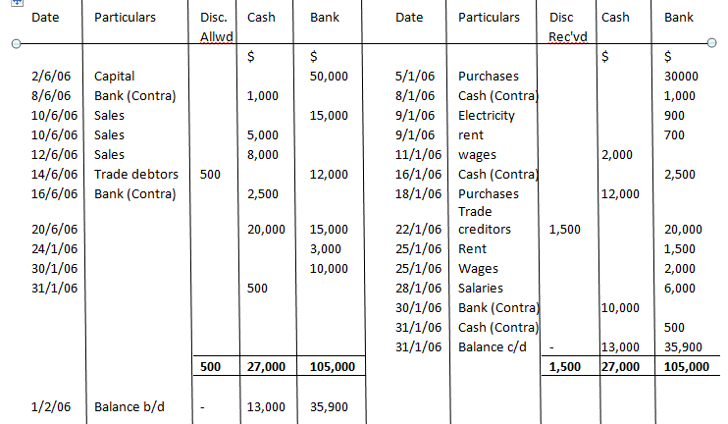

Figure 1: Sample Double Colum Cash Book

**ii) Sales Day Book (Sales Journal):** Records all credit sales transactions made by the business. It usually includes details such as the date of the sale, the name of the customer, the invoice number, and the amount of the sale.

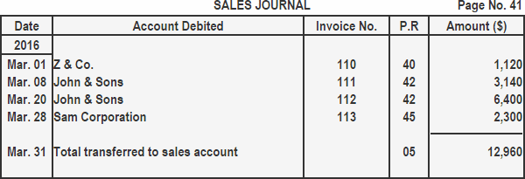

Figure 2: Sample Sales Journal or sales day book

**iii) Purchase Day Book (Purchases Journal):** Records all credit purchases of goods or services made by the business. Similar to the sales day book, it includes details such as the date of purchase, the name of the supplier, the invoice number, and the amount of the purchase.

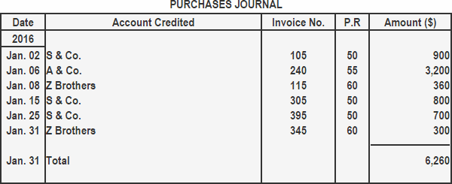

Figure 3: Sample purchases journal

**iv) Sales Returns Book:** Records all goods returned by customers. It includes details such as the date of the return, the name of the customer, the original invoice number, and the value of the goods returned.

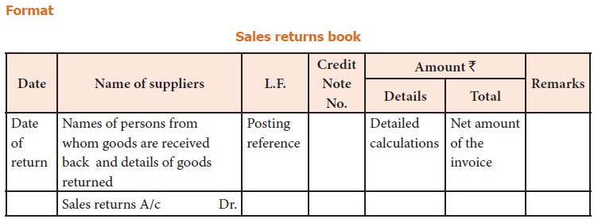

Figure 4: Sample sales returns book

**v) Purchase Returns Book:** Records all goods returned to suppliers. It includes details such as the date of the return, the name of the supplier, the original invoice number, and the value of the goods returned.

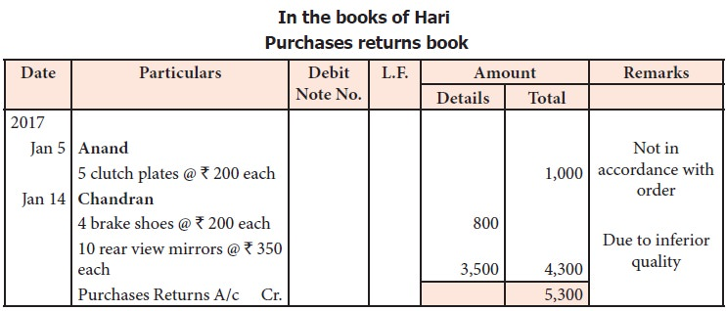

Figure 5: Sample purchases returns book

**vi) Journal Proper:** Records all transactions that do not fit into any of the specialized journals mentioned above. These may include adjusting entries, accruals, depreciation, and other miscellaneous transactions.

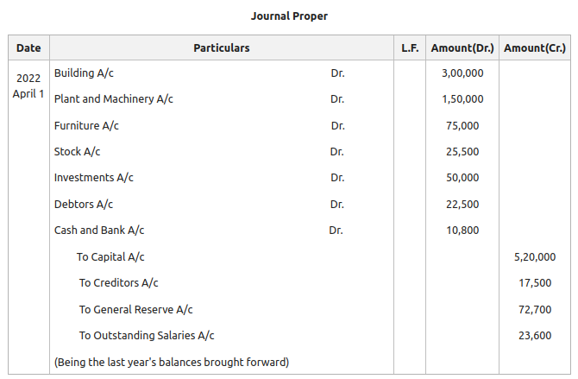

Figure 6: Sample journal proper

**vii) Petty Cash Book:** Records small, miscellaneous expenses paid out of petty cash. It includes details such as the date of the expenditure, the purpose of the expenditure, and the amount spent.

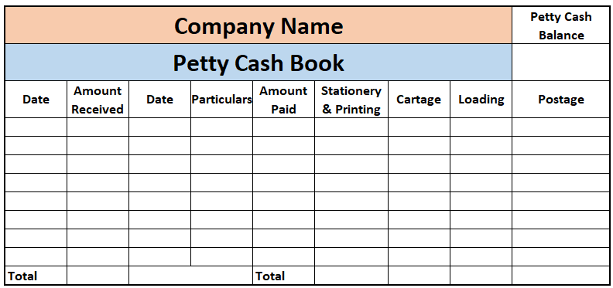

Figure 7: Sample petty cash book

These books of original entry serve as the primary records of financial transactions and provide a chronological record of the company's activities. Entries from these books are later summarized and posted to the general ledger accounts.

**2.3. The Ledger and the Concept of Double Entry**

The accounting ledger, also known as the general ledger, is a principal book or file that contains all the accounts used by a company to record transactions. Each account in the ledger represents a specific aspect of the company's financial transactions, such as assets, liabilities, equity, revenue, and expenses. Here's an overview of the accounting ledger:

**a) Chart of Accounts:** Before transactions are recorded in the ledger, a chart of accounts is established. This chart defines the categories or types of accounts the company will use to organize its financial information. Common account categories include assets, liabilities, equity, revenue, and expenses. Each account is assigned a unique account number and name for identification purposes.

**b) Recording Transactions:** When a business transaction occurs, it is initially recorded in a journal, such as the general journal or specialized journals like sales and purchases journals. These transactions are then posted to the appropriate accounts in the ledger. The ledger serves as the central repository for all transactions affecting the company's financial position.

**c) Account Structure:** Each account in the ledger typically follows a standardized structure. It includes:

Account Name: Describes the nature of the account, such as "Cash," "Accounts Receivable," or "Sales Revenue."

i) Account Number: A unique identifier assigned to each account for easy reference and organization.

ii) Debit and Credit Columns: Transactions are recorded as debits and credits, with each transaction affecting at least two accounts. Debits and credits are entered into their respective columns in the ledger.

iii) Balance: The ledger maintains a running balance for each account, representing the cumulative effect of all transactions recorded in that account.

**d) Posting Entries:** Posting involves transferring information from the journal entries to the appropriate accounts in the ledger. Each journal entry affects at least two accounts, with one account debited and another credited. The debits and credits are posted to the ledger accounts, ensuring that the accounting equation (Assets = Liabilities + Equity) remains in balance.

**e) Trial Balance:** Periodically, typically at the end of an accounting period, the ledger is used to prepare a trial balance. This report lists all the accounts and their balances (debit or credit) to ensure that total debits equal total credits, verifying the accuracy of the ledger entries.

**f) Financial Reporting:** The information stored in the ledger serves as the basis for preparing financial statements, such as the balance sheet, income statement, and cash flow statement. These statements provide stakeholders with an overview of the company's financial performance and position.

Overall, the accounting ledger is a fundamental tool for recording, organizing, and summarizing a company's financial transactions, providing essential information for decision-making and financial reporting purposes.

**The Concept of Double Entry**

The concept of double-entry accounting is a fundamental principle in accounting that states that for every transaction, there are at least two accounts involved, with one account debited and another credited. This system ensures that the accounting equation, Assets = Liabilities + Equity, remains in balance at all times.

Here's how the double-entry accounting system works:

**a) Every Transaction Involves Two Accounts:** In double-entry accounting, every financial transaction affects at least two accounts. One account is debited (recorded on the left side), and another account is credited (recorded on the right side). The total debits must always equal the total credits.

**b) Debits and Credits:** Debits and credits are not inherently positive or negative. Instead, they represent the increase or decrease in the balance of an account. The rules for debits and credits depend on the type of account:

i) Asset Accounts: Debits increase the balance, and credits decrease the balance.

ii) Liability and Equity Accounts: Credits increase the balance, and debits decrease the balance.

iii) Revenue Accounts: Credits increase the balance, and debits decrease the balance.

iv) Expense Accounts: Debits increase the balance, and credits decrease the balance.

The Accounting Equation: The double-entry system ensures that the accounting equation (Assets = Liabilities + Equity) remains in balance after every transaction. Each transaction affects both sides of the equation, maintaining the equality between assets, liabilities, and equity.

**c) Recording Transactions:** When a transaction occurs, it is initially recorded in a journal, such as the general journal. The journal entry includes the accounts affected, the amounts debited and credited, and a brief description of the transaction. These journal entries are then posted to the appropriate accounts in the general ledger.

**d) Trial Balance:** Periodically, typically at the end of an accounting period, a trial balance is prepared to verify the accuracy of the ledger accounts. The trial balance lists all the accounts and their balances (debit or credit), ensuring that total debits equal total credits.

**e) Financial Statements:** The information recorded using the double-entry system forms the basis for preparing financial statements, such as the balance sheet, income statement, and cash flow statement. These statements provide valuable insights into a company's financial performance and position.

Overall, the double-entry accounting system provides a systematic and reliable method for recording and summarizing financial transactions, ensuring accuracy, integrity, and consistency in financial reporting.

**2.4. The Trial Balance**

A trial balance is a financial statement that lists all the accounts in the general ledger along with their respective debit or credit balances. Its purpose is to ensure that the total debits equal the total credits, which helps to verify the accuracy of the recording and posting of transactions in the accounting system.

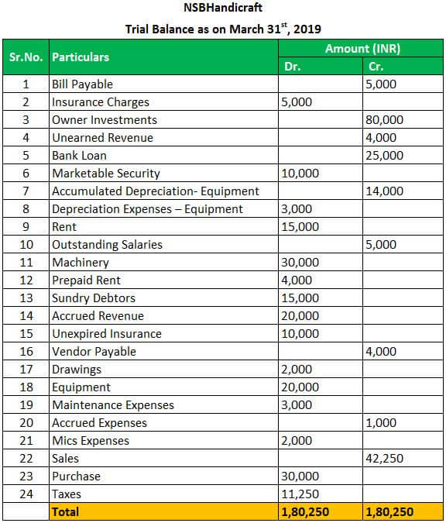

Figure 8: Sample trial balance

**Key Features of a Trial Balance**

**Listing of Accounts**: The trial balance includes a list of all accounts from the general ledger. Each account is listed along with its account number and balance.

**Debits and Credits:** The trial balance shows the balances of each account as either a debit or credit amount. Debit balances are listed in one column, and credit balances are listed in another column.

**Totaling of Balances:** The total of all debit balances is calculated and listed at the bottom of the debit column. Similarly, the total of all credit balances is calculated and listed at the bottom of the credit column.

**Equality Check:** The trial balance verifies that the total debits equal the total credits. If the accounting system is functioning correctly and all transactions have been recorded accurately, the total debits should equal the total credits.

**Identifying Errors:** If the trial balance does not balance (i.e., if the total debits do not equal the total credits), it indicates that there may be errors in the recording or posting of transactions. Common errors include:

i) Posting a transaction to the wrong account

ii) Omitting a transaction from the ledger

iii) Recording a transaction with incorrect amounts

iv) Errors in calculations

**Preparation Frequency:** Trial balances are typically prepared at the end of an accounting period, such as monthly, quarterly, or annually, as part of the closing process. They serve as an important step in preparing financial statements and ensuring the accuracy of the company's financial records.

It's important to note that while a balanced trial balance is a good indication of accuracy, it does not guarantee that the financial statements are error-free. Further analysis and review of individual transactions and account balances are necessary to ensure the integrity of the financial information.

**2.5. Financial Statements**

Accounting financial statements are formal records of a company's financial activities and position, typically prepared at the end of an accounting period (e.g., monthly, quarterly, or annually). These statements provide valuable insights into the financial health, performance, and position of a business. The main financial statements include:

i) The statement of financial position or the balance sheet

ii) The income statement

iii) Cash flow statement

iv) Statement of changes in equity

**The Balance Sheet**

The balance sheet, also known as the statement of financial position, is one of the primary financial statements that provides a snapshot of a company's financial position at a specific point in time. It presents the company's assets, liabilities, and equity, and it follows the fundamental accounting equation:

*Assets = Liabilities + Equity*

**Sample Statement of Financial Position**

**ABC Limited**

**Balance sheet as at 31 March 2000**

|  |  |  |  |
| --- | --- | --- | --- |
|  | **Sh.** | **Sh.** | **Sh.** |
| **Long Term Assets** |  |  |  |
| Freehold property (Net book value)  Plant and machinery (Net book value)  Motor vehicles (Net book value)  Furniture and fittings (Net book value)  Current Assets:  Stocks  Debtors  Investments  Current liabilities:  Trade creditors  Bank overdraft  Corporation tax  Dividends payable  Equity  Authorised share capital – 800,000  Sh.1 ordinary shares  Issued and fully paid: 400,000 Sh.1 Ordinary shares  Capital reserve  Revenue reserve  Loan capital: 400,000 10% Sh.1 Debentures | 238,400  878,400  176,000  107,200 | 1,000,000  400,000  120,000  1,500,000  (1,400,000) | 480,000  800,000  200,000  200,000  1,680,000  120,000  1,800,000  400,000  200,000  800,000  400,000  1,800,000 |

**Key Components of the Balance Sheet**

**a) Assets**

Assets represent what the company owns and can include tangible items like cash, inventory, property, plant, and equipment (PP&E), as well as intangible assets like patents and trademarks. Assets are typically classified into current assets and non-current assets.

**i) Current Assets:** These are assets expected to be converted into cash or used up within one year or the normal operating cycle of the business, whichever is longer. Examples include cash, accounts receivable, inventory, and short-term investments.

**ii) Non-current Assets:** Also known as long-term assets, these are assets expected to provide economic benefits beyond one year. Examples include property, plant, and equipment (PP&E), long-term investments, and intangible assets like patents and goodwill.

**b) Liabilities**

Liabilities represent what the company owes to external parties, such as creditors and suppliers. Liabilities are also classified into current liabilities and non-current liabilities.

**i) Current Liabilities:** These are obligations expected to be settled within one year or the normal operating cycle of the business, whichever is longer. Examples include accounts payable, short-term loans, and accrued expenses.

**ii) Non-current Liabilities:** Also known as long-term liabilities, these are obligations that are due beyond one year. Examples include long-term loans, bonds payable, and deferred tax liabilities.

**c) Equity**

Equity represents the ownership interest in the company. It is the residual interest in the assets of the entity after deducting liabilities. Equity is composed of several components, including:

**i) Share Capital:** The amount of capital contributed by shareholders through the issuance of shares.

**ii) Retained Earnings:** The accumulated profits or losses of the company that have not been distributed to shareholders as dividends.

**iii) Additional Paid-in Capital:** Any additional amount received from shareholders in excess of the par value of shares issued.

**iv) Accumulated Other Comprehensive Income (OCI):** Unrealized gains or losses that are not included in **net income but are reported directly in equity.**

**v) Treasury Stock:** Shares of the company's own stock that have been repurchased and are held in the company's treasury.

The balance sheet provides valuable insights into a company's liquidity, solvency, and overall financial health. It is an essential tool for investors, creditors, and other stakeholders to assess a company's financial position and make informed decisions.

**The Income Statement**

The income statement, also known as the profit and loss statement (P&L), is one of the primary financial statements that reports a company's financial performance over a specific period of time, typically a month, quarter, or year. It summarizes the company's revenues, expenses, gains, and losses, and ultimately shows whether the company has generated a profit or incurred a loss during the period.

Sample Income Statement

**ABC Limited**

**Income Statement**

**For the Year Ended 31st December 2023**

|  |  |  |
| --- | --- | --- |
|  | Sh”000” | Sh”000” |
| **Sales** |  | 400 |
| Less Cost of Sales |  |  |
| Opening Inventory | 50 |  |
| Add Purchases | 100 |  |
| Less Closing Inventory | (70) |  |
| **Cost of Goods Sold** | (80) | (80) |
| **Gross Profit** |  | 320 |
| **Less Expenses** |  |  |
| Salaries and Wages |  | (70) |
| Rent |  | (40) |
| Electricity |  | (30) |
| Insurance |  | (20) |
| Audit fees |  | (10) |
| Interest Expenses |  |  |
| Net Profit |  | 150 |

**Components of the Income Statement**

**a) Revenues**

Revenues, also known as sales or turnover, represent the income generated from the sale of goods or services. Revenue is recognized when goods are delivered, services are rendered, or other criteria for revenue recognition are met. Types of revenues include:

i) Sales Revenue: Income from the sale of goods or services to customers.

ii) Interest Revenue: Income earned from interest on loans, investments, or other financial instruments.

iii) Dividend Revenue: Income received from dividends on investments in stocks or other equity securities.

**b) Expenses**

Expenses represent the costs incurred by the company in the process of generating revenue and operating the business. Expenses are deducted from revenues to calculate the company's net income. Common types of expenses include:

i) Cost of Goods Sold (COGS): The direct costs associated with producing or purchasing the goods sold by the company.

ii) Operating Expenses: These are expenses incurred in the day-to-day operations of the business, such as salaries, rent, utilities, marketing, and administrative expenses.

iii) Interest Expenses: The cost of borrowing money, such as interest on loans or bonds.

iv) Depreciation and Amortization: The systematic allocation of the cost of long-term assets over their useful lives.

v) Income Tax Expenses: The taxes owed by the company on its taxable income.

**c) Gains and Losses**

Gains and losses represent income or expenses that are not directly related to the company's core operations. They are typically from non-operating activities and may include:

Gains: Income generated from non-operating activities, such as the sale of investments, assets, or subsidiaries at a profit.

Losses: Expenses incurred from non-operating activities, such as asset write-downs, impairments, or losses on the sale of investments or assets.

**Net Income (or Net Loss)**

Net income is the final line item on the income statement and represents the company's profit or loss for the period. It is calculated by subtracting total expenses (including losses) from total revenues (including gains). If revenues exceed expenses, the result is net income. If expenses exceed revenues, the result is a net loss.

The income statement provides valuable insights into a company's profitability and performance. It helps investors, creditors, and other stakeholders assess the company's ability to generate profits, manage expenses, and sustain its operations over time.

**The Cash Flow Statement**

The cash flow statement is one of the primary financial statements that provides information about a company's cash inflows and outflows over a specific period of time. It helps stakeholders understand how cash is generated and used by the company, providing insights into its liquidity, solvency, and ability to meet financial obligations.

The cash flow statement is divided into three main sections:

**1) Operating Activities:** This section reports cash flows from the company's primary business operations. It includes cash receipts from customers and cash payments to suppliers, employees, and other operating expenses. The operating activities section reflects the company's ability to generate cash from its core operations. Typical items included in this section are:

i) Cash received from customers for the sale of goods or services.

ii) Cash paid to suppliers and vendors for inventory and other operating expenses.

iii) Cash paid to employees for wages and salaries.

iv) Cash paid for operating expenses such as rent, utilities, and insurance.

v) Interest received and paid related to operating activities.

**2) Investing Activities:** This section reports cash flows from the buying and selling of long-term assets, investments, and other non-current assets. It reflects the company's investments in capital expenditures and other long-term assets. Typical items included in this section are:

i) Cash paid for the purchase of property, plant, and equipment (PP&E).

ii) Cash received from the sale of PP&E or other long-term assets.

iii) Cash paid for investments in securities such as stocks and bonds.

iv) Cash received from the sale of investments or collection of dividends.

v) Loans made to other entities or proceeds from the repayment of loans.

**3) Financing Activities:** This section reports cash flows related to the company's financing activities, such as raising capital and repaying debt. It reflects changes in the company's capital structure and financing arrangements. Typical items included in this section are:

i) Cash received from issuing stocks or bonds.

ii) Cash received from borrowing money through loans or lines of credit.

iii) Cash paid for the repurchase of company stock (buybacks).

iv) Cash paid for dividends to shareholders.

v) Cash proceeds from the repayment of debt or other financing arrangements.

At the end of each section, the net cash flow is calculated by summing the cash inflows and outflows. The net cash flow from each section is then added together to calculate the overall change in cash and cash equivalents for the period.

The cash flow statement is a valuable tool for investors, creditors, and other stakeholders to assess a company's ability to generate cash, manage liquidity, and fund its operations, investments, and financing activities. It complements the income statement and balance sheet by providing a more comprehensive view of a company's financial performance and position.

**The Statement of Changes in Equity**

The statement of changes in equity, also known as the statement of shareholders' equity or statement of retained earnings, is one of the financial statements that reports the changes in a company's equity over a specific period of time. It provides details about the factors that contributed to the change in the equity section of the balance sheet.

Here's a breakdown of the components of the statement of changes in equity:

**a) Beginning Equity:** The statement typically starts with the beginning balance of equity from the previous period, which is carried forward from the balance sheet.

**b) Contributions and Distributions**: This section includes any changes in equity resulting from transactions with shareholders, such as the issuance of new shares or the repurchase of existing shares. It also includes any distributions to shareholders, such as dividends.

i) Issuance of Shares: When a company issues new shares of common stock, the proceeds received from the issuance increase the equity section of the balance sheet.

ii) Repurchase of Shares: If a company repurchases its own shares (treasury stock), it reduces the equity section of the balance sheet.

iii) Dividends: Distributions to shareholders reduce the retained earnings portion of equity.

**c) Net Income or Loss:** This section represents the net income or loss generated by the company during the period. Net income increases equity, while net losses decrease equity. The net income or loss is transferred from the income statement to the statement of changes in equity.

**d) Other Comprehensive Income (OCI):** OCI includes gains and losses that bypass the income statement and are recorded directly in equity. Examples of items included in OCI are unrealized gains or losses on available-for-sale securities, foreign currency translation adjustments, and pension adjustments. OCI can have either a positive or negative impact on equity.

**e) Ending Equity**: The statement concludes with the ending balance of equity, which is the sum of the beginning equity, contributions and distributions, net income or loss, and other comprehensive income.

The statement of changes in equity helps stakeholders understand how a company's equity position has changed over time and the factors that contributed to those changes. It provides transparency into the company's capital structure, financing activities, and retained earnings. The statement of changes in equity is typically included in the set of financial statements along with the balance sheet, income statement, and cash flow statement.